Familiarize with Postman

Learning Objectives
- Explore and understand target API
- Learn API testing operations in Postman from to create a workspace, collection, and folder
- How to create your first Rest API request
- Dynamize requests with environment variables
- Write postman test
- Executing test script locally

Target API
The API that we will test here is a demo API, which is provided freely on the following site: https://jsonplaceholder.typicode.com/.

Explore and understand target API
- Understand API structure by drawing entity relationship diagram;
- Map out endpoints, available actions and possible status codes;
- Figure out relationship across endpoints

Create a workspace
Postman workspaces enable you to organize and work together on API projects with your team. Within each workspace you can share APIs, collections, environments, and other Postman elements.
When you first open Postman, you will be in your default personal workspace. You can create more workspaces for your personal use and to work with teammates. To create more workspaces, you need to sign in to your Postman account.
To create a new workspace, do the following:
- Select Workspaces in the upper left. Select Create Workspace to add a new workspace. You can also search for existing workspaces using the search bar or select one from the dropdown list.
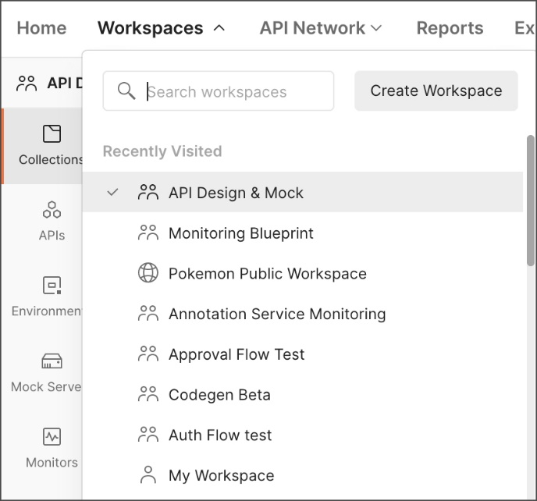
- Enter a Name and optional Summary for your workspace.
- Choose the workspace's visibility:
- A Personal workspace is visible only to you.
- A Team workspace is visible to everyone on your team.
- A Public workspace is visible to all Postman users.
- Select Create Workspace.
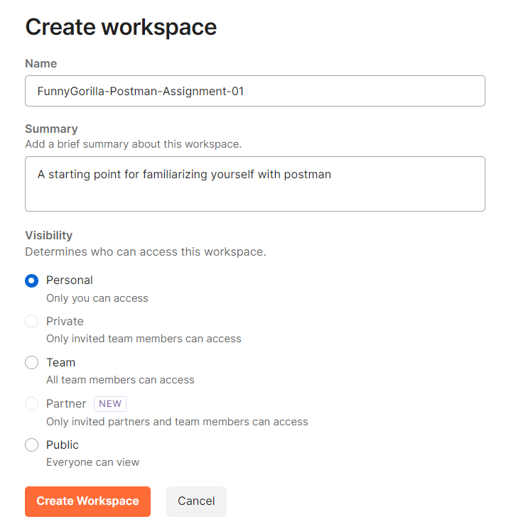
Postman will switch to your new workspace when you create it. You can move between workspaces at any time by selecting from the dropdown Workspaces list in the upper left.

Create a collection
In Postman, any request that we test must be added to a directory called Collection, which provides storage for requests and allows for better organization.
We will, therefore, create a DemoBook collection that will contain the requests to the demo API, and for this, we will perform the following tasks:
- In Postman, in the left-hand panel, click on the Collections | + button.
- Once the tab opens, we will enter the name DemoBook. These steps for creating a new collection are illustrated in the following screenshot:
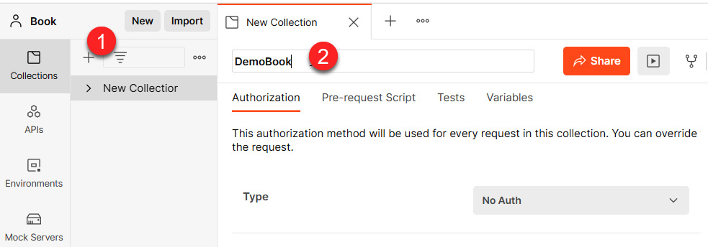
Figure 3 – Postman collection creation
So, we have a Demobook collection that appears in the left-hand panel of Postman.
This collection is also synchronized with our Postman web account, and we can access it at https://web.postman.co/me/collections.
This collection will allow us to organize the requests of our API tests, and it is also possible to modify its properties in order to apply a certain configuration to all the requests that will be included in this collection.
These properties include request authentication, tests to be performed before and after requests, and variables common to all requests in this collection.
To modify the settings and properties of this collection, perform the following actions:
- Click on the ... button of the context menu of the collection.
- Choose the Edit option, and the edit form appears, in which we can change all the settings that will apply to the requests in this collection.
- Switch between all configuration tabs for the edit authorization, scripts, tests, or variables options.
- The following screenshot shows the steps that are taken to modify the properties of a collection:
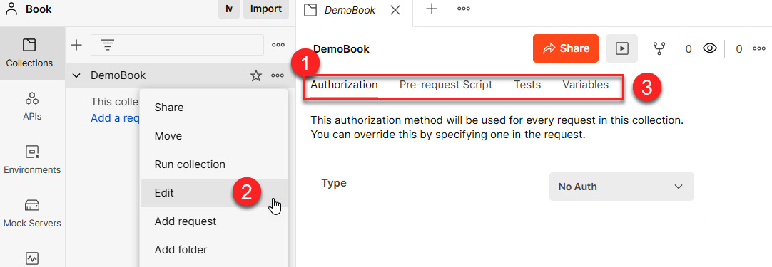
Figure 4 – Postman edit collection
So, we have discussed the procedure that is followed in order to create a collection that is the first Postman artifact, and this will allow us to organize our API test requests.
We will now create a request that will call and test the proper functioning of our demo API.

Create first request
In Postman, the object that contains the properties of the API to be tested is called a request.
This request contains the configuration of the API itself, but it also contains the tests that are to be performed to check that it is functioning properly.
The main parameters of a request are as follows:
- The URL of the API
- Its method: GET/POST/DELETE/PATCH
- Its authentication properties
- Its querystring keys and its body request - google query string
- The tests that are to be performed before or after execution of the API
The creation of a request is done in two steps – its creation in the collection, followed by its configuration.
Step one: create a request
To create the request of our API, here are the steps that need to be followed:
- We go to the context menu of the DemoBook collection and click on the Add Request option:
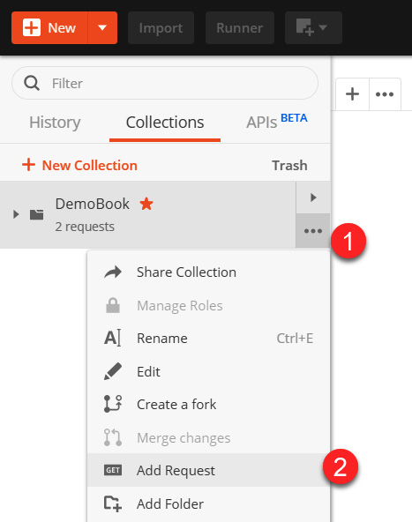
Figure 5 – Add Request in Postman
- Then, in the new tag, enter the name of the request, Get all posts, as shown in the following screenshot:
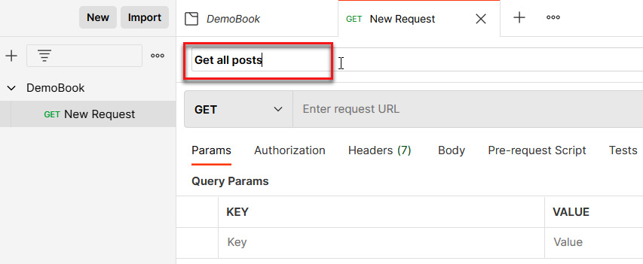
Figure 6 – Get all posts in Postman
Step two: The configuration of the request
After creating the request, we will configure it by entering the URL of the API to be tested, which is https://jsonplaceholder.typicode.com/posts, in the GET method. After entering the URL, we save the request configuration by clicking on the Save button.
The following screenshot shows the parameters of this request with its URL and method:
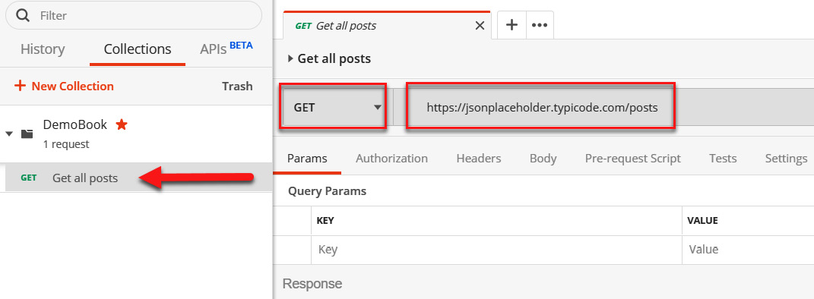
Figure 7 – Postman edit request
Finally, to complete the tests, and to add more content to our lab, we will add a second request to our collection, which we will call Get a single post. It will test another method of the API, and it will also ensure that we configure it with the https://jsonplaceholder.typicode.com/posts/<ID of post> URL.
The following screenshot shows the requests of our collection:
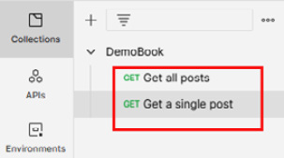
Figure 8 – Postman request list
NOTE
Note that the Postman documentation for collection creation can be found at https://learning.getpostman.com/docs/postman/collections/creating_collections/.

Use environments and variables to dynamize requests
When we want to test an API, we need to test it on several environments for better results. For example, we will test it on our local machine and development environment, and then also on the QA environment. To optimize test implementation times and to avoid having a duplicate request in Postman, we will inject variables into this same request to make it testable in all environments.
So, in the following steps, we will improve our requests by creating an environment and two variables; then, we will modify our requests in order to use these variables:
- In Postman, we will start by creating an environment that we call Local, as shown in the following screenshot:
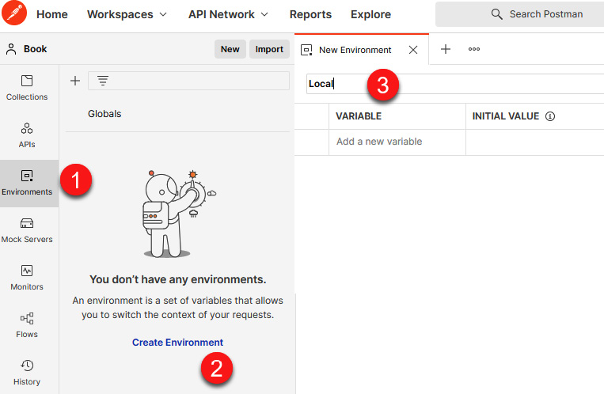
Figure 9 – Adding an environment in Postman
- Then, in this Local environment, we will insert a variable named PostID, which will contain the value to pass in the URL of the request. The following screenshot shows the creation of the PostID variable:
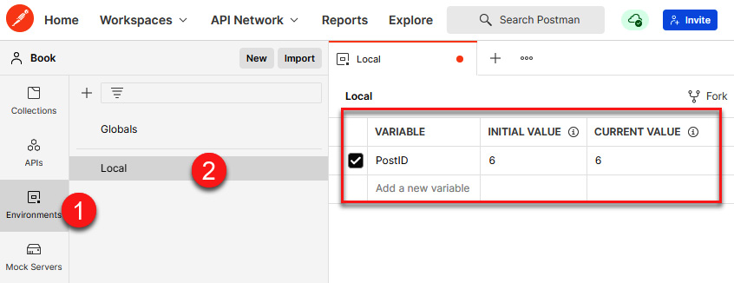
Figure 10 – Adding an environment variable in Postman
- Thus, for the Local environment, the value of the PostID variable is 6. To have a different value for other environments, it is necessary to create other environments using the same steps that we have just seen, and then add the same variables (with the same name) and their corresponding values. This, for example, shows the variable screen for the QA environment:
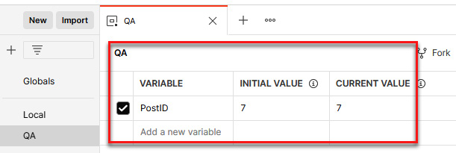
Figure 11 – Adding a second environment in Postman
- Finally, we will modify the request in order to use the variable that we have just declared. In Postman, the usage of a variable is done using the {{variable name }} pattern. So, first, we select the desired environment from the dropdown in the top-right corner. Then, in the request, we will replace the post's ID at the end of the URL with {{PostID}}, as shown in the following screenshot:
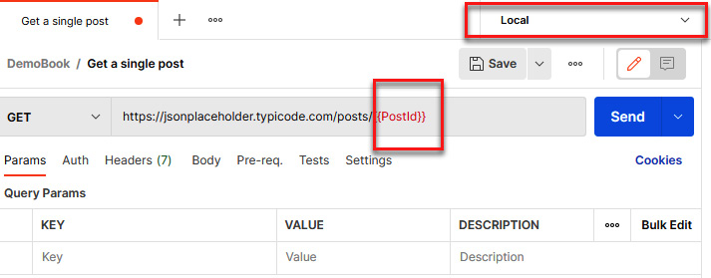
Figure 12 – Using a variable environment in Postman
NOTE
Note that the Postman documentation of environments and variables is available at https://learning.getpostman.com/docs/postman/environments_and_globals/intro_to_environments_and_globals/.
In this section, we created a Postman request that will allow us to test an API. Then we made its execution more flexible by creating an environment in Postman that contains variables that are also used in Postman's requests.
In the next section, we will write Postman tests to verify the API result.

Write Postman tests
The first thing when testing an API is to make sure the API responses successfully, which is indicated by response code 200. Think about why? Testing an API is not only about checking that its call returns a return code of 200, that is, that the API responds well, but also that its return result corresponds to what is expected, or that its execution time is not too long.
For example, consider an API that returns a response in JSON format with several properties. In the tests of this API, it will be necessary to verify that the result returned is a JSON text that contains the expected properties, and even more so to verify the values of these properties.
In Postman, it is possible to write tests that will ensure that the response of the request corresponds to the expected result in terms of return or execution time using the JavaScript language.
Postman tests are written in the Tests tab of the request:
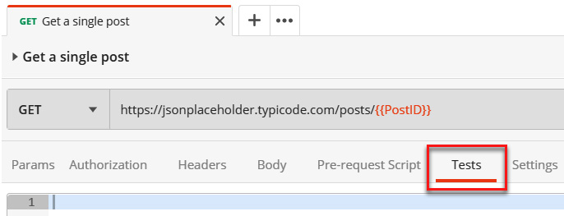
Figure 13 – Postman Tests tab
To test our request, we will write several tests, which are as follows:
- That the return code of the request is 200
- That the response time of the request is less than 400 ms
- That the answer is not an empty JSON
- That the return JSON response contains the userId property, which is equal to 1
To perform these tests, we will write the code for the following in the Tests tab.
The following code illustrates the return code of the request:
pm.test("Status code is 200", function () {
pm.response.to.have.status(200);
});
The following code illustrates a response time of less than 400 ms:
pm.test("Response time is less than 400ms", function () {
pm.expect(pm.response.responseTime).to.be.below(400);
});
The following code illustrates that the response in JSON format is not empty:
pm.test("Json response is not empty", function (){
pm.expect(pm.response).to.be.json;
});
The following code illustrates that, in the JSON response, the userId property is equal to 1:
pm.test("Json response userId eq 1", function (){
var jsonRes = pm.response.json();
pm.expect(jsonRes.userId).to.eq(1);
});
And so, finally, the Tests tab of our request, which tests our API, contains all this code, as shown in the following screenshot:
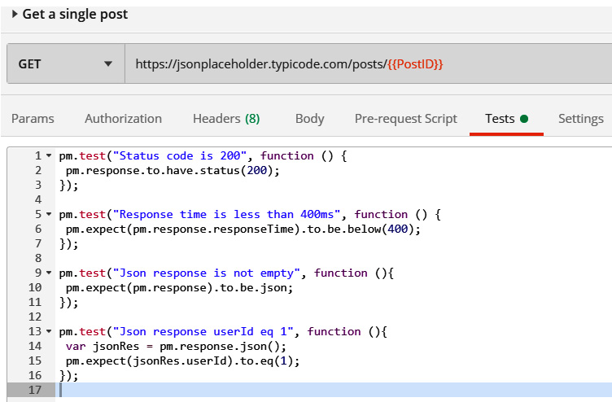
Figure 14 – Postman Tests code
We have completed our Postman request with test writing, which will check the proper functioning of the API according to its feedback code, performance, and response content.
NOTE
For more information about the Postman tests and scripts, you can read the documentation at https://learning.getpostman.com/docs/postman/scripts/intro_to_scripts.
In this section, we have just seen how, in Postman, we can write API tests to check the proper functioning of our API. We will now run our Postman request locally in order to test our API.

Executing Postman request tests locally
So far, in Postman, we have created a collection in which two requests contain the parameters and tests of our APIs that are to be tested. To test the proper functioning of the APIs with their parameters and tests, we must now execute our requests that are in Postman. Note that it will only be at the end of this execution that we will know whether our APIs correspond to our expectations.
To execute a Postman request, perform the following actions:
- You must first choose the desired environment.
- Click on the Send button of the request, as shown in the following screenshot:
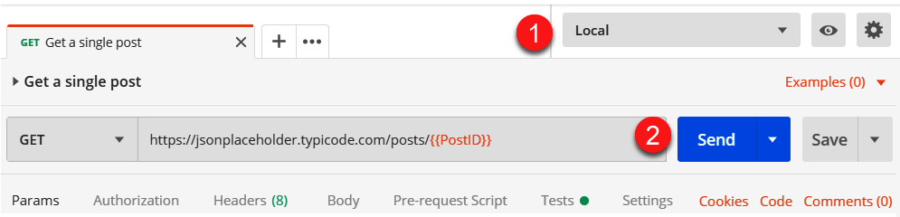
Figure 15 – Postman signup
- In the Body tab, we can then view the content of the query response, and if we want to display it in JSON format, we can choose the display format. The following screenshot shows the response of the request displayed in JSON format:
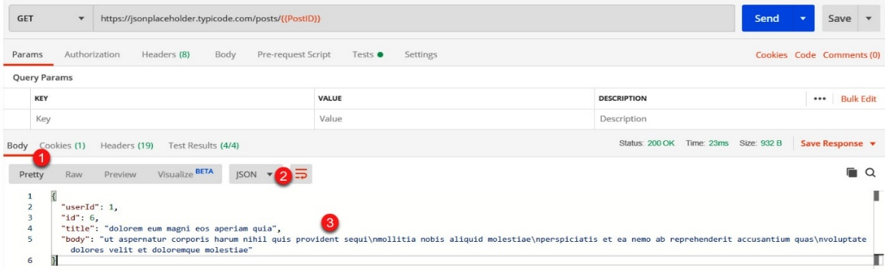
Figure 16 – Postman body response
- The Test Results tab displays the results of the execution of the tests that we previously wrote, and in our case, the four tests have been executed correctly—they are all green, as shown in the following screenshot:
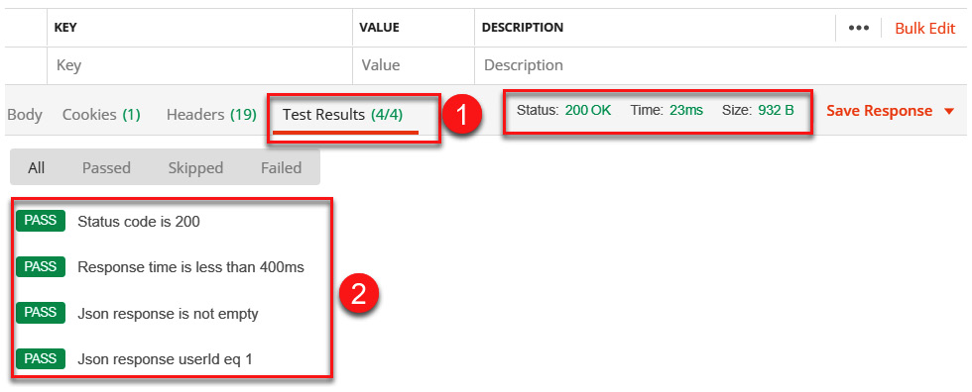
Figure 17 – Postman Test Results
In the preceding screenshot, we can see that the return code of the Postman request is equal to 200, which corresponds to the request's successful execution return code, and its execution time of 23 ms, which is below the threshold (400 ms) that I set for myself as an example.
In the event that one of the tests fails, it will be displayed in red to clearly identify it. An example of a failed test is shown in the following screenshot:
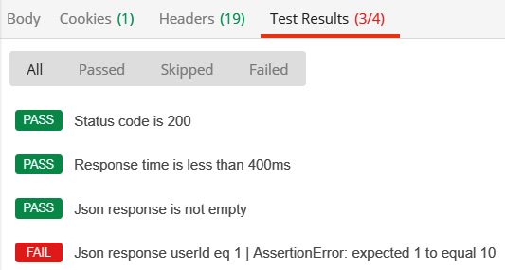
Figure 18 – Postman test failed
We have just seen the execution of a Postman request to test an API, but this execution is only for the current request. If we want to execute all Postman requests in a collection, we can use Postman Collection Runner.
Postman Collection Runner is a Postman feature that automatically executes all the requests in a collection in the order in which they have been organized.
You can learn more about the Collection documentation by visiting https://learning.getpostman.com/docs/postman/collection_runs/starting_a_collection_run/.
The following two screenshots show the Runner execution steps, in which we choose the collection to execute, the environment, and the number of iterations. To start its execution, we click on the Run DemoBook button:
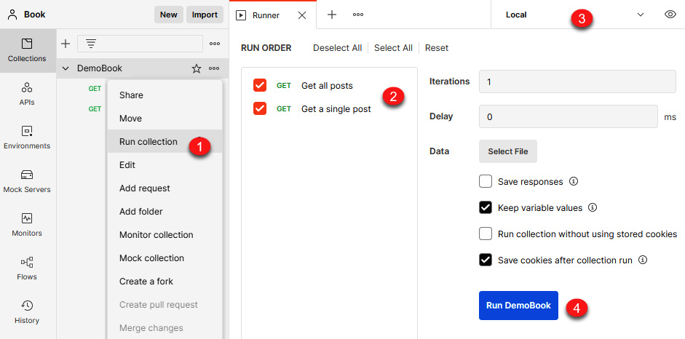
Figure 19 – Postman Runner
And so, in the Runner tab, we can see the test execution result of all the requests in the collection, as shown in the following screenshot:
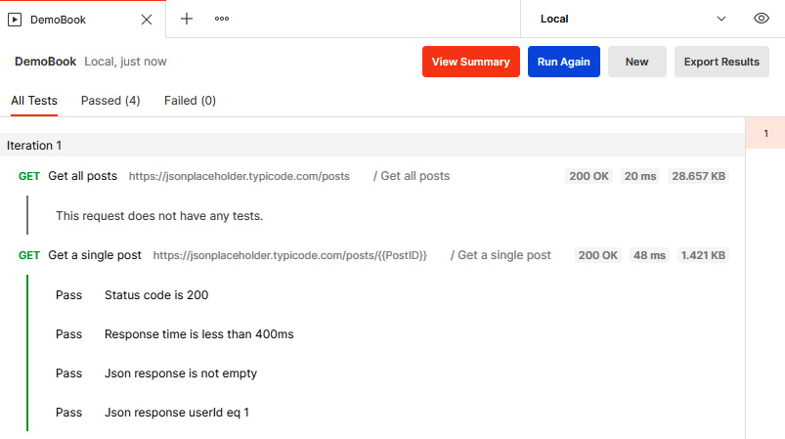
Figure 20 – Postman Runner execution
NOTE
The documentation for Postman Runner can be found at https://learning.getpostman.com/docs/postman/collection_runs/intro_to_collection_runs.
In this section, we have learned how to execute Postman requests in order to test an API in a unitary way, before executing all the requests in the collection using Postman Runner.

Summary
By finishing this assignment you have learned how to explore and test an API by postman.

